Setup of Ubuntu Server 14.04.1
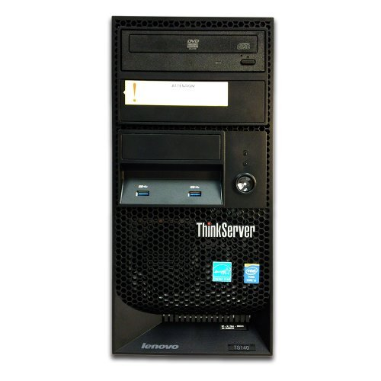
Lenovo TS140 ThinkServer
Purchased from Computer Upgrade King ($230 with 1 stick of RAM)
Processor: Intel® Core i3-4130 processor 3.4 GHz, 2C, 4M Cache, 1.00 GT/s, 65W
RAM: 2 x 4 GB PC3-12800E 1600MHz DDR3 ECC-UDIMM UDIMM / 4 Slots Total
Hard Drive: NONE installed with 3 vacant 3.5'' bays / RAID: Software supporting 0, 1, 5 Levels
Optical Drive: DVD-ROM / Power Supply: 280W Fixed / Networking: Gigabit Ethernet (Integrated)

I added a 2TB WD Hard Drive

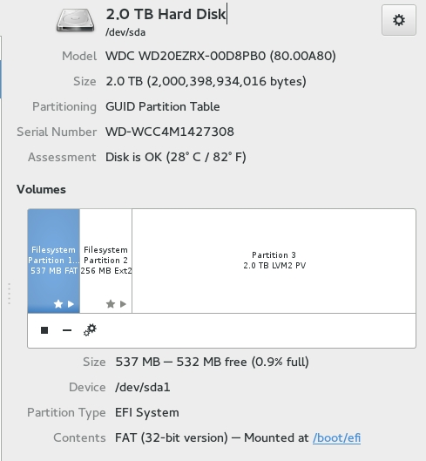

I then installed Ubuntu Server 14.04.1 LTS; http://www.ubuntu.com/download/server
I followed David Goguda’s extremely detailed YouTube video, How to Make an Ubuntu File Server; https://www.youtube.com/watch?v=ndAYZ0DJ-U4 (Preview video)
In order to have a graphical interface, I added a stripped down Gnome desktop graphical user interface. From the terminal:
sudo apt-get install xorg gnome-core gnome-system-tools gnome-app-install

Network Upgrade: I connect to the Internet via an AT&T DSL connection

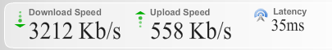
I replaced my Netgear N300 Wireless Gigabit ADSL2+ modem/router DGN3500 with a stand-alone modem.
I chose a Netgear Broadband ADSL2+ modem model DM111PSP and an Asus RT-AC66R wireless AC-1750 router.

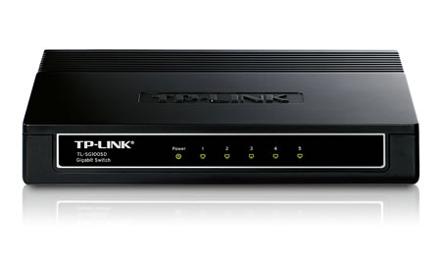
In order to improve the wireless range of the Asus router, I mounted it near the ceiling and ran a cable from it to a, TP-Link TL-SG1005D 5 port Gigabit Desktop switch I have a second identical switch on my desktop

I also use a Netgear model WN2500RP Dual Band WiFi Range Extender; an Apple Airport Extreme, a Netgear Wireless N access point model WN802T and several generic Ethernet switches
Here is a screen shot of my Local Area Network
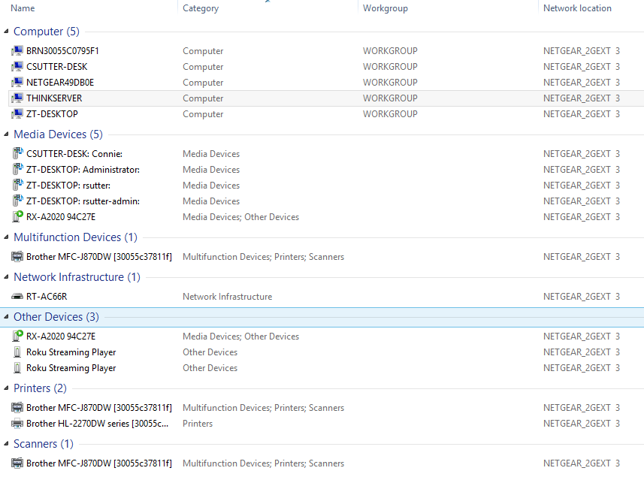

Here are screen shots of the details shown by my Asus router
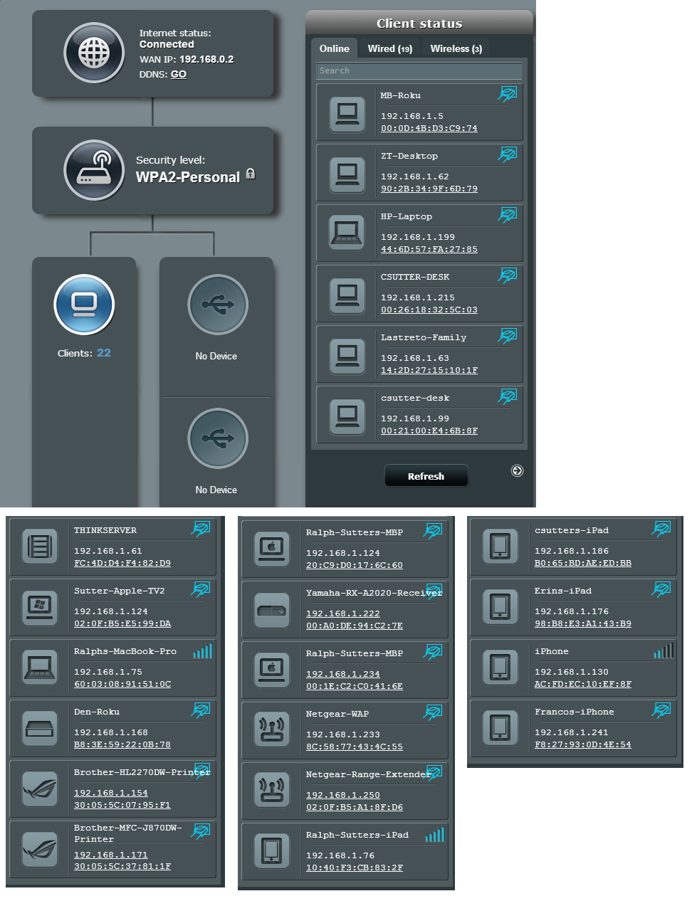
Linux Newbie Resources
Linux commands tutorial
http://lowfatlinux.com/linux-tutorial.html

The useful content begins at
http://lowfatlinux.com/linux-basics.html

Newbie Server Questions
1. I’m running the ThinkServer box from the Gnome GUI. If I check for updates and upgrades, will it just check for files on the Gnome desktop or will it also check for Ubuntu 14.04.1 Server?
2. Currently, when I try to access ThinkServer from my Yamaha receiver, I don’t see it. I see other computers on the network but not ThinkServer. I suspect that the other computers are being seen as media servers. What do I do to see ThinkServer from my Yamaha RX-A2020? Do I install MediaTomb?
MediaTomb how to video at https://www.youtube.com/watch?v=qic11JxRbN8
Does MediaTomb replace Ubuntu server or does it run on top of Ubuntu server?

