SLOBYTES HTML SIG

Web page building exercise

SLOBYTES HTML SIG web site is located at http://htmlsig.topcities.com/index.html.

You will find help pages http://htmlsig.topcities.com/resources.html
Practice making a web page by choosing one of the templates.
Look at the source code and modify it to suit your own needs.
Name your page with your last name, sutter.html, and save it on a floppy.

Validate the page at http://www.htmlhelp.com/tools/validator/direct.html by pasting the code into the window provided for that purpose.

Once that you have successfully validated the page, open a file transfer protocol (FTP) program such as
WS_FTP or WS_FTP Lite and upload the page to http://htmlsig.topcities.com/members/yourname.html
You may download a shareware copy of WS_FTP Lite (free for noncommercial use) from
www.gabn.net/junodj/ws_ftp32.htm

Here is additional information that you will need to upload your page:
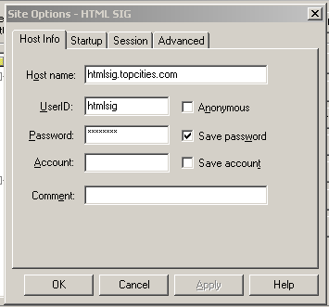

Note that:
The Host Name is htmlsig.topcities.com
The User ID is htmlsig
The Password is 5PhpI5ug

Again, here is the minimal html code.

<html><head><title>SOME TITLE</title></head>
<body>
Insert your text here. See template for additional tags.
</body></html>

Last modified on 11/03/2002

